**ALTHue Philips Hue plugin**

* Alternate implementation of Philips Hue plugin
* Supports v2 bridges
* Manage Hue devices exactly like VERA devices
* Supports all lamps, Support Hue Motion sensor
* UI7 and ALTUI support ( UI5 support is limited for now, known issues: RGB wont work & Hue plugin icon is not showing up )

**Why another one**

* More reliable
* Supports motion sensor, temp sensor, lux sensor & battery
* Code less ugly and messy
* All devices appear strictly as standard vera devices, supporting same service/variable, same Upnp actions

Lets jump into it

1. Installing the plugin
2. Configuring the plugin
3. Playing with the plugin

# Installing the plugin

Prerequisite : your Philips Hue Hub is installed, connected and works fine to command devices

## Method 1 : Install from MCV store

Open a browser and type open this url , ignore the error message reported and let VERA reload a couple of times

* http://<ip>:3480/data_request?id=action&serviceId=urn:micasaverde-com:serviceId:HomeAutomationGateway1&action=CreatePlugin&PluginNum=9066&Version=36104

## Method2 : install from Github

1)download files from https://github.com/amg0/ALTHue

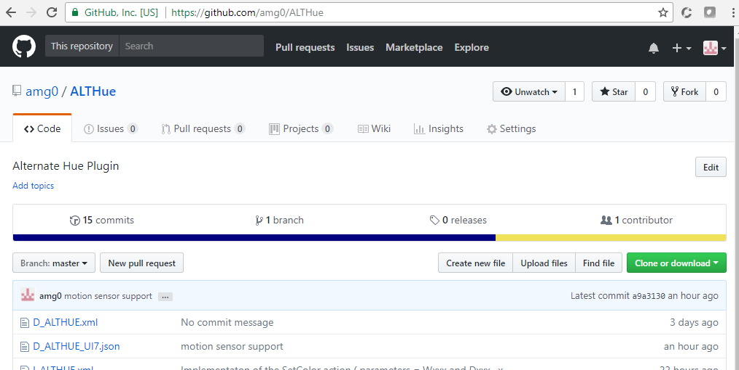

2)upload them in VERA and enable reload of luup after

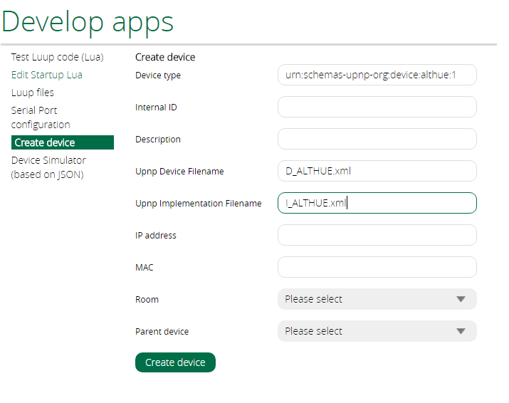

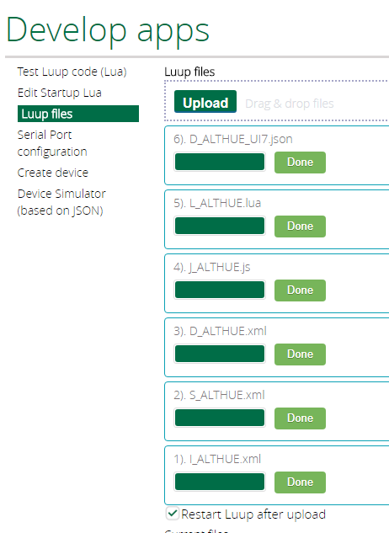

3)create a device manually

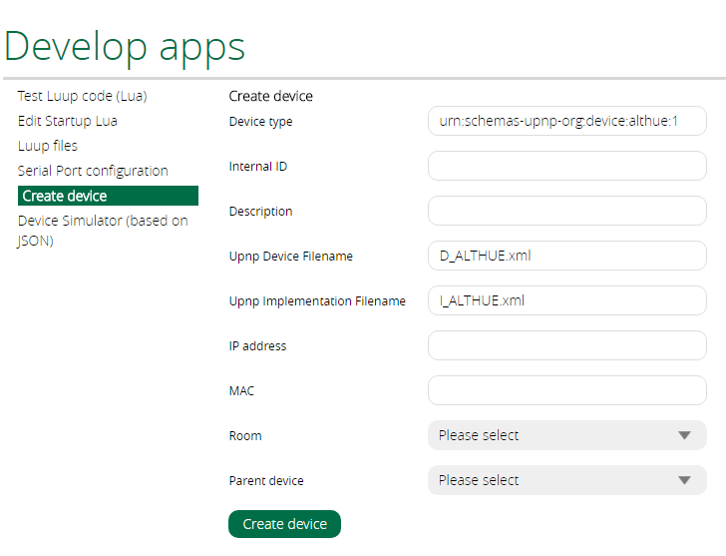

4) reload the engine

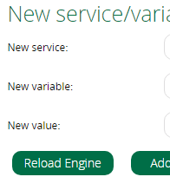

# Configuring the plugin

1. You should have an error message in the UI7



And find your device in “error” mode in the list of devices

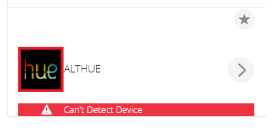

1. You need to configure the IP address of the Philips Hub. For this you go into settings tab and either enter IP address or select it from the proposed discovered ones

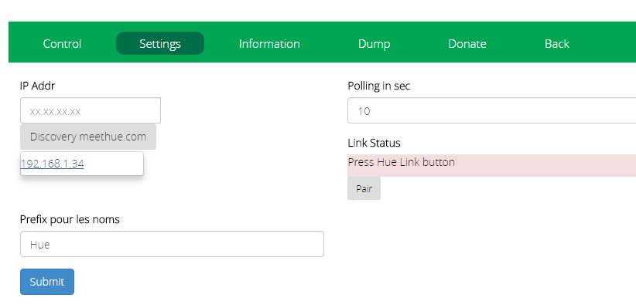

1. Set IP address and click submit. Wait for the luup reload to happen
2. Now the Pairing with the Hue device must be done. You will have 30 seconds to press on the central big button of the Hue hub , then click on the “Pair” button of the settings screen. Once everything is ok , you should get that confirmation on the screen:  
   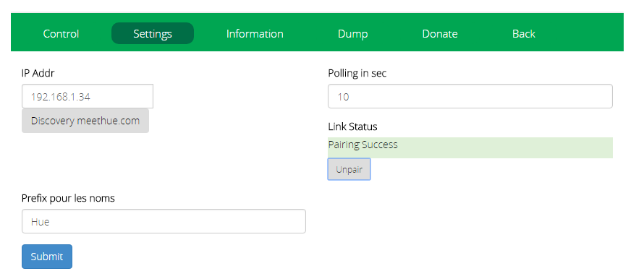

The variable Credentials will contain the User ID given to you by Philips Hub and which appear in the whitelist of users in the Philips Hub configuration

1. Force a engine reload again. Since many children devices will be created there could be several reloads of the engine, be patient and refresh your browser page. You should be rewarded by a working plugin  
   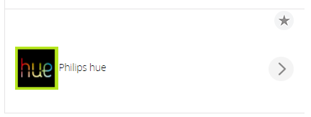

# Playing with the plugin

In the plugin settings Information page, you find a list of your Light and Sensor devices. The Dump page is for debug and gives you the full bridge JSON structure.  
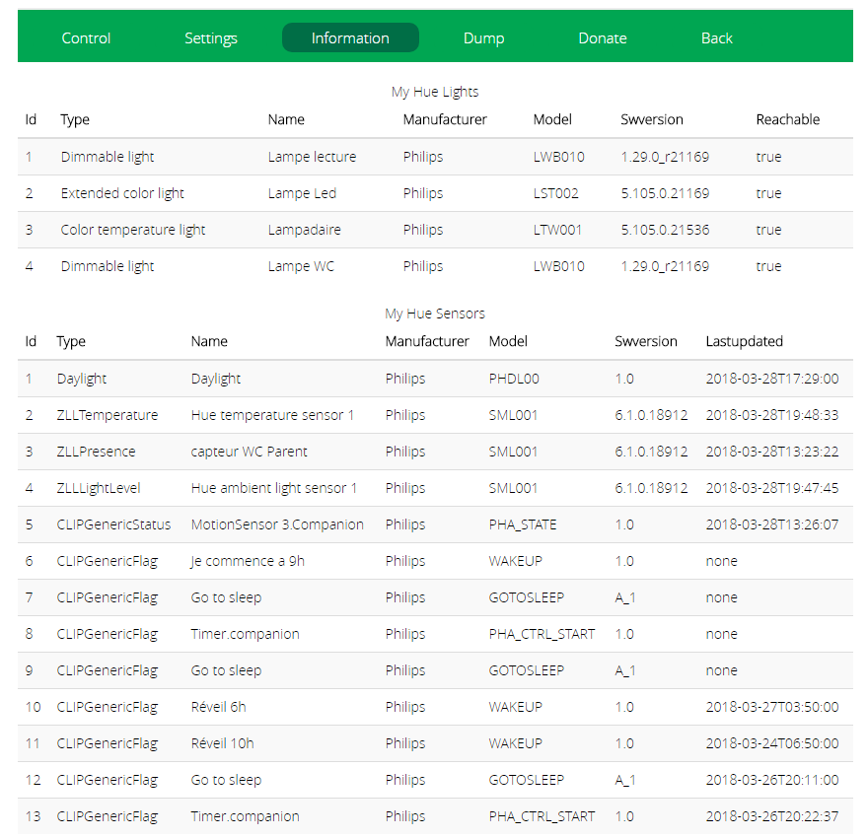

1. All devices must have been created. Either as a standard Dimmer device, or as a standard RGB Dimmer device. The Hue motion sensor contains temp and lux sensor so 3 devices are created as std motion sensor, Lux sensor and temp sensor. These devices can be used in vera scenes

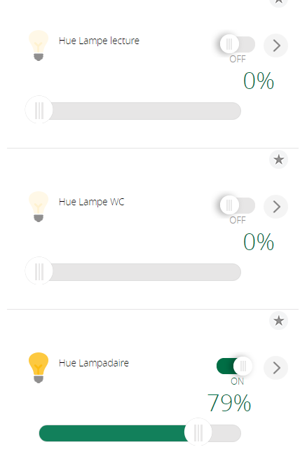

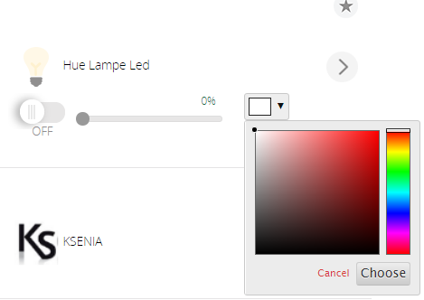

The battery information is also collected:

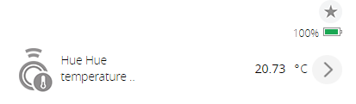

1. Support this development and use the Donate settings page at your convenience

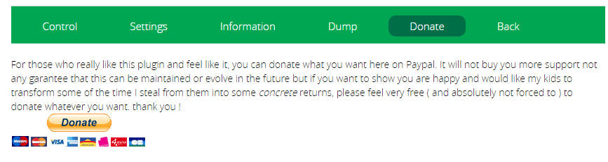

1. Full ALTUI support is also granted  
   